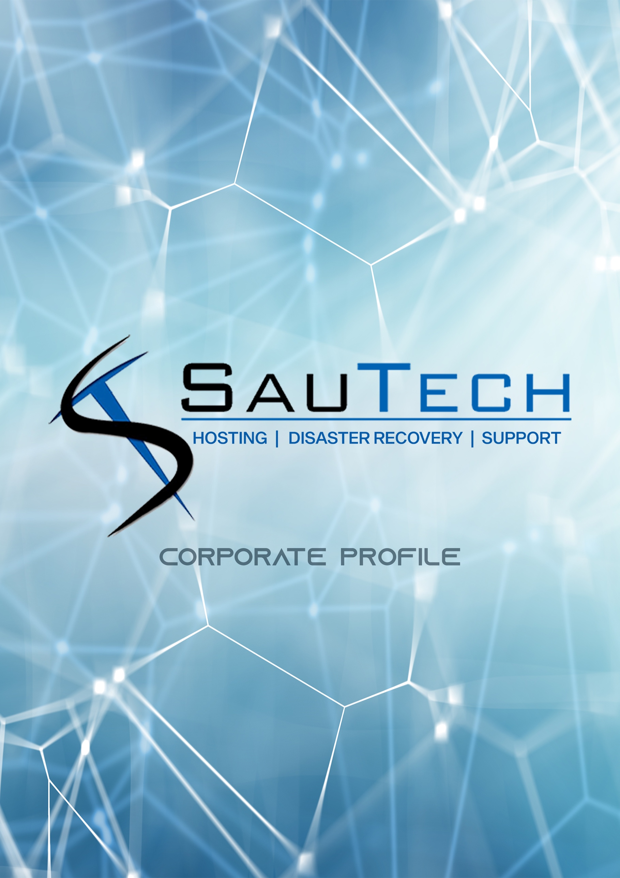

Established in 2003, Sautech has experience in multiple projects, clients and technologies.

To list a few industries, projects and skill sets Sautech was either involved in or offer:

- Financial services

- Small, Medium and Blue-Chip Organizational Hosting and Security

- Government and Political Party Hosting Top Tier Provider of Security

- Infrastructure for ISP’s

- Managed Services

- Disaster Recovery Outsourced Provider

- Internet Connectivity Ransomware Protection, Consulting and Recovery

- Ethical Hacking and Penetration Testing

- Network Design Consulting

International Hosting to various industries in other countries hosted in South Africa

Sautech is not industry focused or service providers for only specific areas within an industry.

Although we have standard services, our added value is that we design specific solutions or consulting for projects, infrastructures or security application implantations.
We have worked either directly or indirectly (outsourced) as consultants or dedicated engineers in the South African Stock Exchange market by either connectivity, security or infrastructure design, Disaster Recovery and business continuity.

We are independent from your current IT service or hosting provider. In most cases we work with your current IT providers to enhance their offering.

Our unique approach to infrastructure design, support and consulting has made Sautech one of the most reputable solutions providers.

Sautech does not deal directly with the public.

Once a computer is infected with ransomware, it will be locked. The user will not be able to access files on their computer as it will be encrypted. The hackers will demand you to pay a ransom - or else all of your files will be deleted. Is your business protected against this?
Ransomware attacks target firms of all sizes and 5% or more of businesses in the top ten industry sectors have already been attacked. Any business, from small-and-medium enterprises to large corporations, can be a potential target.
Attacks are on the rise in every single sector and in every size of business.
Once infected with ransomware, your options are either to pay the ransom, try to remove the malware or wipe the whole system(s) and re-install from scratch.
A ransomware attack can be devastating for a home or business network. Valuable and irreplaceable files can be lost and hours of effort can be required to get rid of the infection and get systems up and running again.
Ransomware attacks continue to evolve and attack methods become more sophisticated by the day. Don’t be part of the statistics. With good planning and smart practices, you can prevent ransomware from affecting your systems.
To be prepared, you need to know how ransomware can enter your workplace and system. These methods of gaining access to your systems are known as attack vectors. Attack vectors can be divided into two types:

- Human Attack Vectors

  - Phishing, SMSishing, Vishing, Social Media and Instant Messaging

- Machine Attack Vectors

  - System Vulnerabilities, Malvertising, Network Propagation and Propagation through shared services
Sautech has the expertise to perform ethical hacking - the systematic attempt to penetrate a computer system or network to source security vulnerabilities that a malicious hacker could potentially exploit.

Once we have identified threats and computer system weaknesses, we deliver a comprehensive consulting plan with a holistic approach on how to solve the vulnerabilities and best practice solutions.

Business continuity planning (BCP) is the process of creating a system for prevention and recovery from potential threats to a company. The plan ensures that staff and assets are protected and are able to function quickly in the event of a disaster. The planning process is conceived in advance and involves input from key stakeholders and staff.
Risks may include natural disasters such as fire, flood, or weather related events, as well as cyber-attacks. Once the risks are identified, the plan should also include:

- Determining how those risks will affect operations

- Implementing safeguards and procedures to mitigate the risks

- Testing procedures to ensure they work

- Reviewing the process to make sure that it is up to date
Sautech offers offsite data backup, replicated virtual servers and applications hosted in our secure data centre. We can assist with secure, offsite Veeam Cloud backup in our 24/7 monitored data centres.

In the event of data loss, cyber-attack or natural disasters affecting your IT infrastructure, we can spin-up a copy of your data in one of our data centres in order for your employees, clients and staff to continue operations, uninterrupted.

Virtual services

VPS is your own virtual private server. Working with virtual servers is the same as dedicated servers. All access and connectivity is managed by Sautech and access to servers are on the same basis as dedicated infrastructure.

VPS gives you computing resources at a lower price when compared to dedicated servers. The flexibility to upgrade resources are easily managed and can be up or down scaled at any time.

Sautech provides the Virtual Infrastructure Hardware and allows you to choose your preferred operating system i.e. Microsoft Windows or Linux Distros.

SauDrive

SauDrive allows you to manage centralised file sharing, space for backups, client documentation and project files, stored security in the cloud.

Sautech manages your backups to an offsite location for continuity and disaster data recovery.

Data is stored in the cloud, where all staff or clients (based on security settings) has access to User Based Backup and Centralized Storage Sharing (SauFileShare)

Security and Firewall

Data integrity and security are the most important items any business has to choose for connectivity and hosting footprint. Not just for compliance, but for disaster data recovery, intellectual property protection and business continuity.

Sautech has partnered with industry leaders to offer tailor made solutions for onsite and offsite security.

IPSEC

Sautech has a centralized firewall VPN server to make branch connectivity secure, centralized and always on. We deploy the primary internet facing security firewall within our datacentre and utilise only checkpoint security devices.
Top 100 of Fortune 100 utilises checkpoint firewall security www.checkpoint.com for Gartner and other reports (Leader, 4 years in a row)
Check Point Software Technologies Ltd. (checkpoint.com), the worldwide leader in securing the internet, provides customers with uncompromised protection against all types of threats, reduces security complexity and lowers total cost of ownership.

Check Point first pioneered the industry with FireWall-1 and its patented stateful inspection technology.

No matter how big or small your company is - or how simple or complex your requirements are - speak to our specialised team to tailor make a package just for you.
No need to pay for pre-packaged services you don’t need.

For more information visit our website www.sautech.net or call us on +27 (0)11 768 1790 or send an email to support@sautech.net

